**Sql Injection With the help of Havij 1.17**

1. **Installation Process:**
2. **Download havij from** <https://hiddenschool24.blogspot.com/2020/03/download-havij-117-pro-cracked.html>
3. **In extract the files to where u want but before that they will ask for password so put it as “ hiddenhacker”**
4. **Run the havij 1.17 pro.exe file and install , before the finish unclick the Launch option**
5. **Move the loader.exe file to to the file location consisting in C drive in my case:**

**C:\Program Files (x86)\ITSecTeam\Havij Pro**

1. **Then create a shortcut for the loader file in present in the above mentioned file location**
2. **In the desktop loader shortcut right click**

**Properties->compatability->click the run as administrator option->apply->ok**

1. **Run the loader file in desktop and in file tab locate the file containing with type of *All files**
2. **Find a site with vulnerabilities**
3. **Copy paste the link of the site in the target**

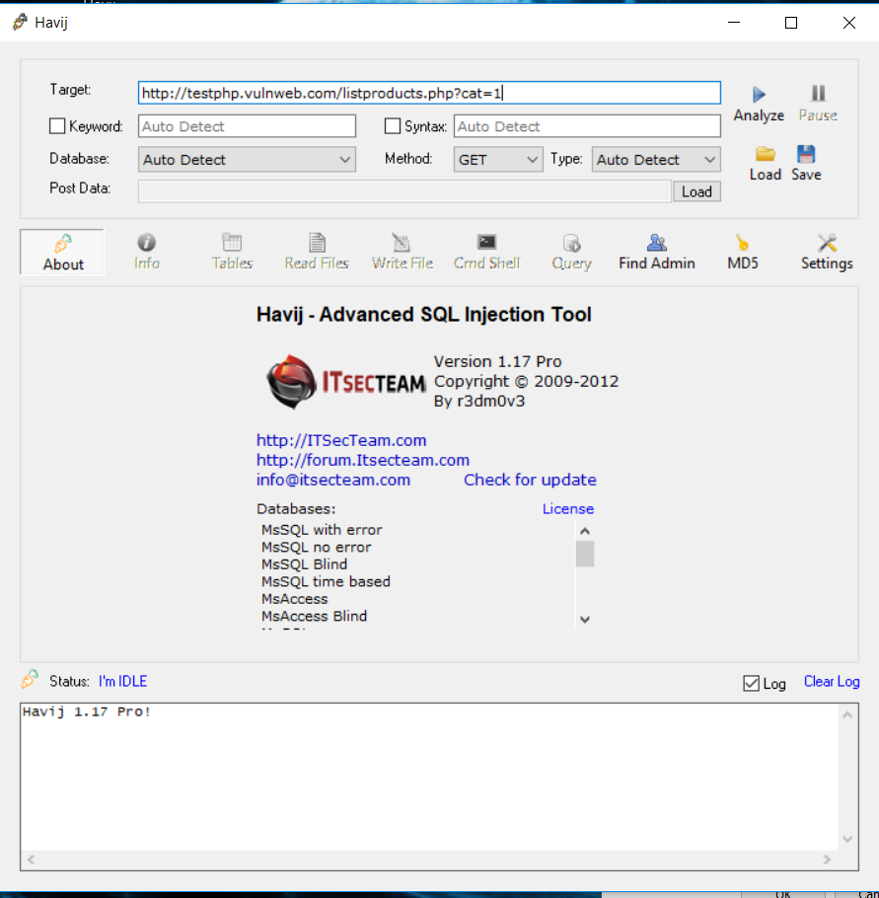

**4)click on analyze it will start injecting to the link**

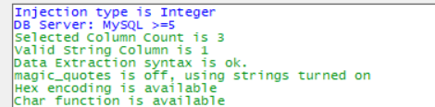

**//unfortunately my havij will not go any futher**

**Its stops when its scanning for the tables**

**Tried for 3 different versions same result**

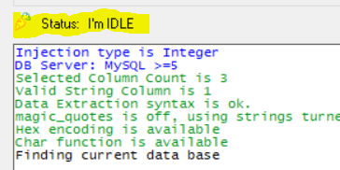

**5)After the status is idle it will show the database that it had found**

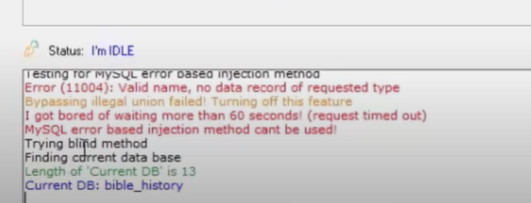

**6)In going to info u will get the information of the site**

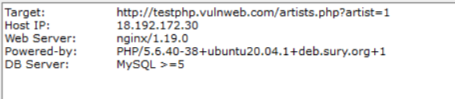

**//actual info in my havij**



**//info taken from different sources**

**7) To check the databases head to Tables**

**8)In tables first click on Get DB(Get database), after that’s done , select the database of your choice and click on get tables of the db, it will display the tables as well as the DB**

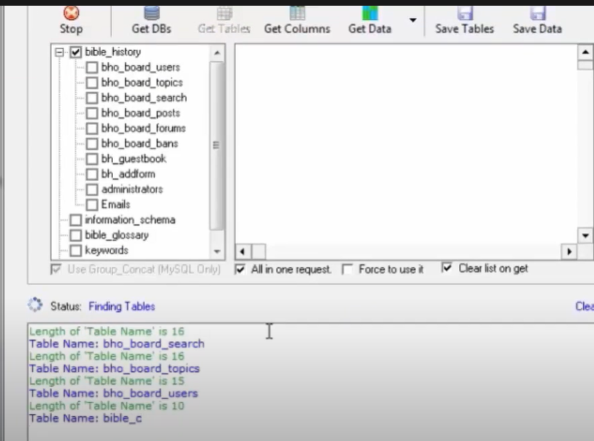

**9)Now to get the actual data go to the tables your choice and then click on get get columns , after getting the columns we can click on get data to show the data stored by the site**

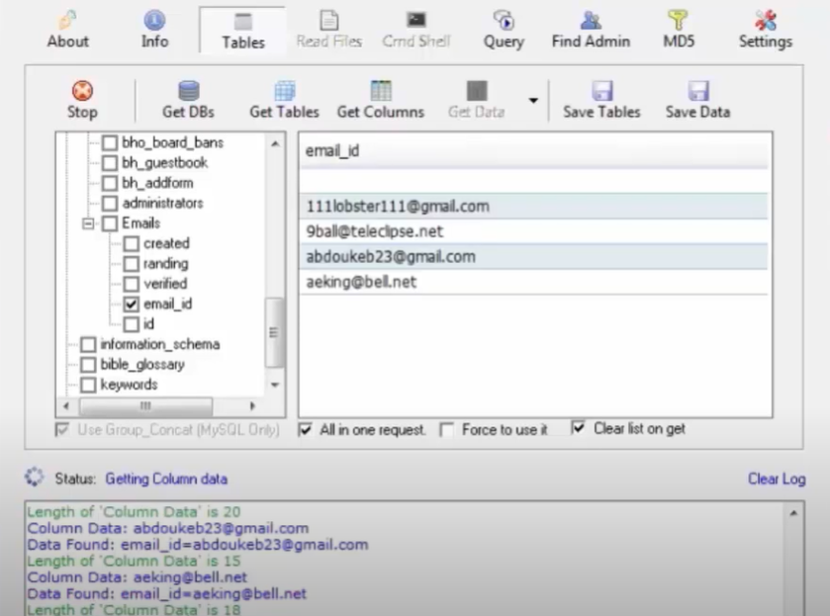

**#NOTE :THESE PROCESSES OF GETTING DATA WILL TAKE A LOT OF TIME**